1. Name each CRUD operation and it’s corresponding Http method.

Create PUT

Read GET

Update PUT

Delete DELETE

1. Why do the Create and Update methods require a Book parameter and the other methods do not?

If you don’t state what record to update it would update all of them with the request

1. Explain the purpose of the CreatedAtRoute method.

It returns a HTTP 201 response. This is the stander response to create a new resource on the server.

1. Do browser screen prints showing the data returned from the Get methods, with and without a book id.

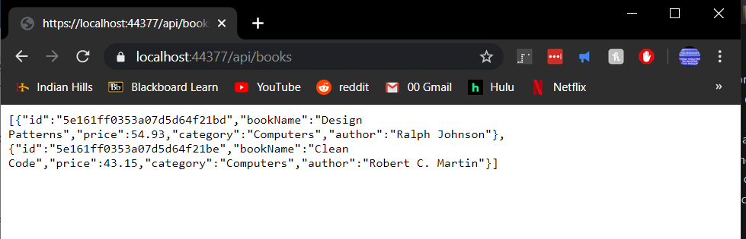

1. What was used to force the JSON field names to match the model class field names?

The property names' default camel casing should be changed to match the Pascal casing of the CLR object's property names. The bookName property should be returned as Name.

1. What was used to override a name derived from the model with a different JSON field name?

[BsonElement("Name")]

[JsonProperty("Name")]

1. Do a browser screen print verifying the new JSON property names.

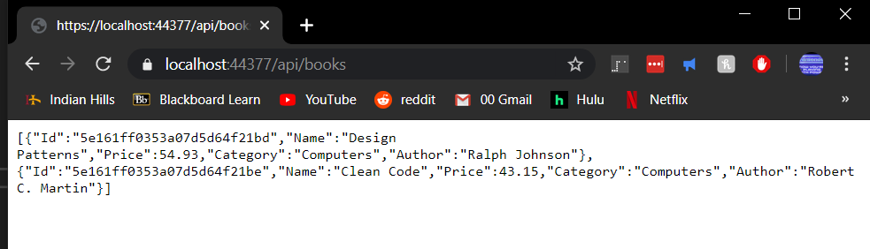

1. Using Postman, do a screen print showing the JSON data returned from a Get request.

